**Pizza sales sql queries**

1. TOTAL REVENUE

SELECT SUM(total_price) AS "Total Revenue" FROM pizzasales;

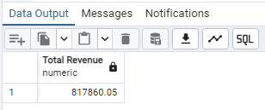

2. AVERAGE ORDER VALUE

SELECT SUM(total_price) / COUNT(DISTINCT order_id) AS "Avg Order Value"

FROM pizzasales;

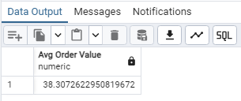

3.TOTAL PIZZAS SOLD

SELECT SUM(quantity) AS "Total Pizza Sold" FROM pizzasales;

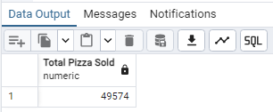

4. TOTAL ORDERS

SELECT COUNT(DISTINCT order_id) AS "Total Order" FROM pizzasales;

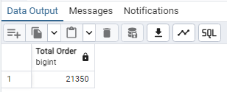

5. AVERAGE PIZZAS PER ORDER

SELECT CAST(CAST(SUM(quantity) AS DECIMAL(10,2)) / CAST(COUNT(DISTINCT order_id) AS DECIMAL(10,2)) AS DECIMAL(10,2)) FROM pizzasales;

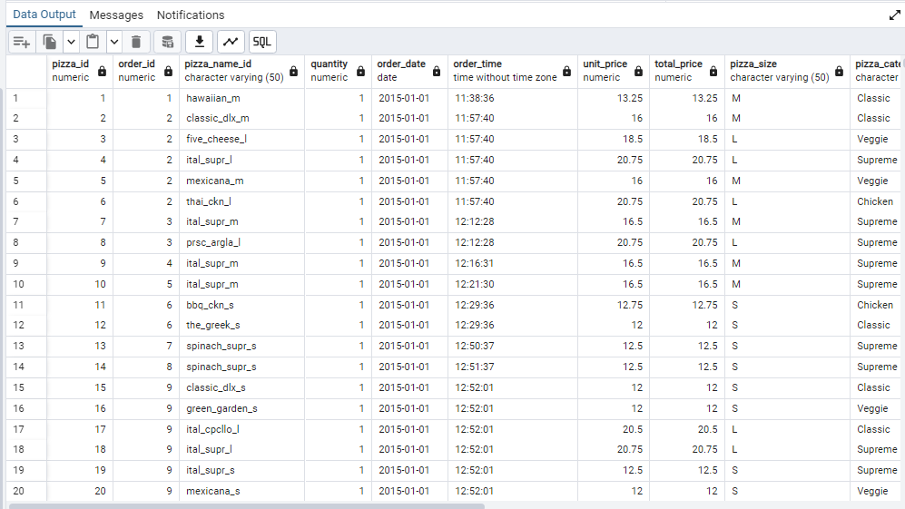

B. HOURLY TREND FOR PIZZAS SOLD

SELECT EXTRACT(HOUR FROM order_time) AS order_hours,

SUM(quantity) AS total_pizzas_sold

FROM pizzasales

GROUP BY EXTRACT(HOUR FROM order_time)

ORDER BY EXTRACT(HOUR FROM order_time);

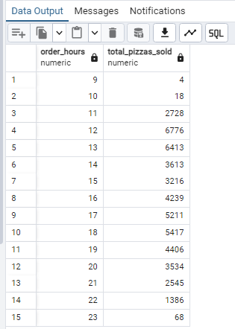

C. WEEKLY TREND FOR ORDERS

SELECT

EXTRACT(WEEK FROM order_date) AS "WeekNumber",

EXTRACT(YEAR FROM order_date) AS "Year",

COUNT(DISTINCT order_id) AS "Total Orders"

FROM

pizzasales

GROUP BY

EXTRACT(WEEK FROM order_date),

EXTRACT(YEAR FROM order_date)

ORDER BY

"Year", "WeekNumber";

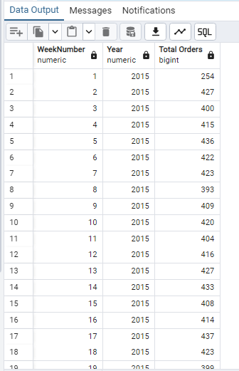

D.PERCENTAGE OF SALES BY PIZZA CATEGORY

SELECT pizza_category, CAST(SUM(total_price) AS DECIMAL(10,2)) AS total_revenue, CAST(SUM(total_price) * 100 / (SELECT SUM(total_price) FROM pizzasales) AS DECIMAL(10,2)) AS pct FROM pizzasales GROUP BY pizza_category;

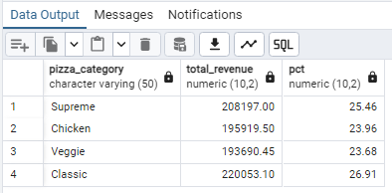

E. PERCENTAGE OF SALES BY PIZZA SIZE

SELECT pizza_size,

CAST(SUM(total_price) AS DECIMAL(10,2)) AS total_revenue,

CAST(SUM(total_price) * 100 / (SELECT SUM(total_price) FROM pizzasales) AS DECIMAL(10,2)) AS pct

FROM pizzasales

GROUP BY pizza_size

ORDER BY pizza_size;

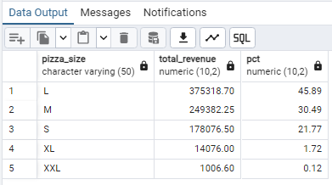

F. TOTAL PIZZAS SOLD BY PIZZA CATEGORY

SELECT pizza_category,

SUM(quantity) AS total_quantity_sold

FROM pizzasales

WHERE EXTRACT(MONTH FROM order_date) = 2

GROUP BY pizza_category

ORDER BY total_quantity_sold DESC;

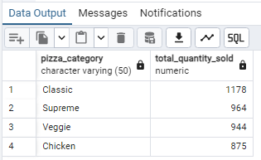

G. TOP 5 PIZZAS BY REVENUE

SELECT pizza_name,

SUM(total_price) AS total_revenue

FROM pizzasales

GROUP BY pizza_name

ORDER BY total_revenue DESC

LIMIT 5;

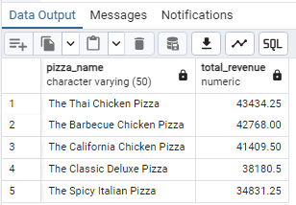

H. BOTTOM 5 PIZZAS BY REVENUE

SELECT pizza_name,

SUM(total_price) AS total_revenue

FROM pizzasales

GROUP BY pizza_name

ORDER BY total_revenue ASC

LIMIT 5;

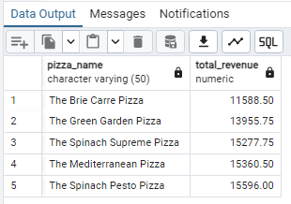

I. TOP 5 PIZZAS BY QUANTITY

SELECT pizza_name,

SUM(quantity) AS total_pizza_sold

FROM pizzasales

GROUP BY pizza_name

ORDER BY total_pizza_sold DESC

LIMIT 5;

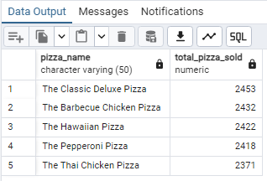

J. BOTTOM 5 PIZZAS BY QUANTITY

SELECT pizza_name,

SUM(quantity) AS total_pizza_sold

FROM pizzasales

GROUP BY pizza_name

ORDER BY total_pizza_sold ASC

LIMIT 5;

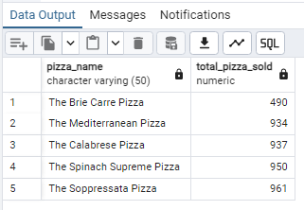

K. TOP 5 PIZZAS BY TOTAL ORDERS

SELECT pizza_name, COUNT(DISTINCT order_id) AS total_orders FROM pizzasales GROUP BY pizza_name ORDER BY total_orders DESC LIMIT 5;

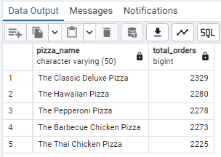

L. BOTTOM 5 PIZZAS BY TOTAL ORDERS

SELECT pizza_name,

COUNT(DISTINCT order_id) AS total_orders

FROM pizzasales

GROUP BY pizza_name

ORDER BY total_orders ASC

LIMIT 5;

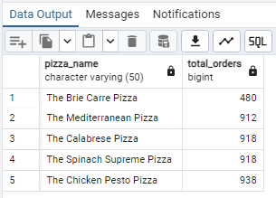

NOTE…….

If you want to apply the pizza_category or pizza_size filters to the above queries you can use WHERE clause. Follow some of below examples

SELECT Top 5 pizza_name, COUNT(DISTINCT order_id) AS Total_Orders

FROM pizza_sales

WHERE pizza_category = 'Classic'

GROUP BY pizza_name

ORDER BY Total_Orders ASC